1.

Simplify 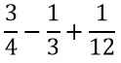
A.
⅓
B.
½
C.
⅙
D.
⅔

2.

Given that N = {x:x is a factor of 18} and M = {x:x is a multiple of 12}, find N ∩ M.
A.
{1,2,3,6}
B.
{1,2,3,6,12}
C.
{2,3,6,12,18}
D.
{}

3.

Express 4382.93 in standard form.
A.
438293 x 10⁴
B.
43.8293 x 10²
C.
4.38293 x 10⁴
D.
4.38293 x 10³

4.

Which property of arithmetic is used in a(x+y) = ax + ay.
A.
Associative
B.
Commutative
C.
Distributive
D.
Initiative

5.

Subtract (7x-3) from (5-3x).
A.
10x-8
B.
4x-8
C.
8-10x
D.
2-10x

6.

The cost of 12 note books is GH₵ 54.84. Find the cost of one note book.
A.
GH₵ 5.57
B.
GH₵ 4.67
C.
GH₵ 4.57
D.
GH₵ 3.57

7.

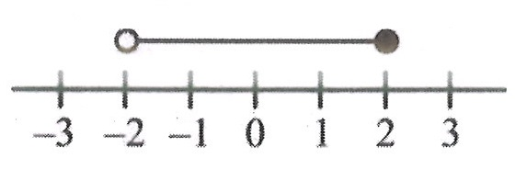
Which of the following inequalities is represented on the number line?
A.
-2>y>2
B.
-2≤ y < 2
C.
-2 ≥ y > 2
D.
-2 < y ≤ 2

8.

Simplify: (2ab²)² x 3a³b.
A.
6a⁴b⁵
B.
12a³b⁴
C.
12a⁶b⁴
D.
12a⁵b⁵

9.

Which of the following polygons does not have a line of symmetry?
A.
Kite
B.
Isosceles triangle
C.
Trapezium
D.
Rhombus

10.

A trader sold a radio set for GH₵ 72.00 making a profit of 8%. Find, correct to the nearest Ghana cedi, the cost of the radio set.
A.
GH₵ 66.00
B.
GH₵ 67.00
C.
GH₵ 77.00
D.
GH₵ 78.00

11.

Vera is 11 years old and her brother is 9 years old. They shared 60 oranges in the ratio of their ages. How many more oranges does Vera get?
A.
6
B.
27
C.
34
D.
39

12.

If (x-3)² = 16, find the positive value of x
A.
1
B.
3
C.
4
D.
7

13.

Find the image of the point (-2,3) under a reflection in the y-axis.
A.
(2,-3)
B.
(-3,2)
C.
(2,3)
D.
(3,2)

14.

What fraction of 3 weeks is 18 days?
A.
⅙
B.
6⁄7
C.
1⁄7
D.
9⁄11

15.

What is the median of the following numbers:
4,16,13,18,3,20,6,7,15,2,10,12?
A.
7
B.
10
C.
11
D.
12

16.

If w/3 = 3(w-1)-1, find the value of w.
A.
3⁄2
B.
5⁄4
C.
3⁄5
D.
1⁄2

17.

Use the diagram below to answer the question below
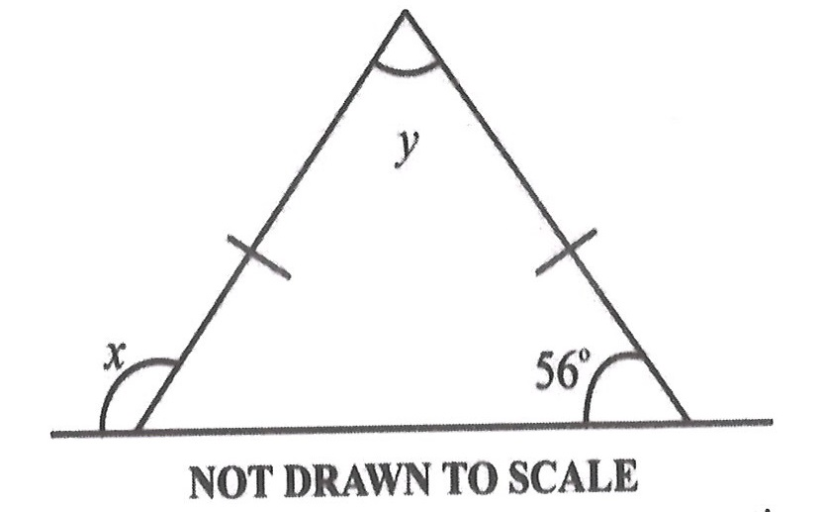
Find the value of x.
A.
68º
B.
75º
C.
112º
D.
124º

18.

Use the diagram below to answer the question below
Find the value of y.
A.
68º
B.
75º
C.
112º
D.
124º

19.

A car used 8 hours to travel from town A to town B at a speed of 18 km/h.
Find the distance travelled.
A.
22.5 km
B.
135 km
C.
140 km
D.
144 km

20.

The pie chart shows the household budget of a family.
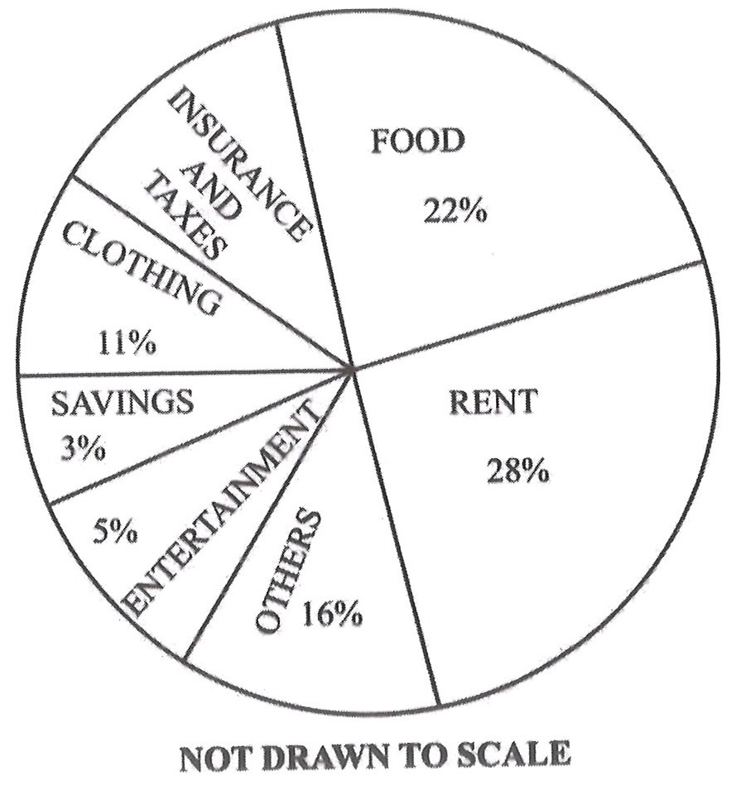
Use the information to answer the question below
Find the angle for INSURANCE AND TAXES.
A.
45º
B.
54º
C.
60º
D.
72º

21.

The pie chart shows the household budget of a family.
Use the information to answer the question below
If the family's income was GH₵ 40,000.00, how much was spent on clothing?
A.
GH₵ 1,600.00
B.
GH₵ 2,000.00
C.
GH₵ 3,200.00
D.
GH₵ 4,400.00

22.

Two sides of a parallelogram are 5.8 m and 8.2 m long. Find its perimeter
A.
11.0 m
B.
36.6 m
C.
28.0 m
D.
47.6 m

23.

A man earned an interest of GH₵ 240.00 in 4 years at 20% per annum simple interest. Calculate the principal
A.
GH₵ 300.00
B.
GH₵ 450.00
C.
GH₵ 480.00
D.
GH₵ 1,200.00

24.

A labourer worked for 20½ hours. If he was paid GH₵ 2.50 per hour, what was his total wage?
A.
GH₵ 51.00
B.
GH₵ 51.25
C.
GH₵ 512.00
D.
GH₵ 512.25

25.

If 480 pupils in a school are boys representing 80% of the school's enrolment. Find the total number of pupils in the school.
A.
384
B.
540
C.
600
D.
864

26.

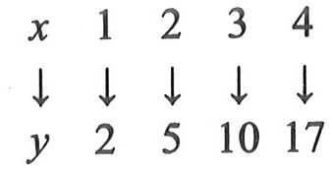
What is the rule for the mapping?
A.
x→ 3x²-1
B.
x→ 5x²-3
C.
x→ x²+1
D.
x→ 4x-2

27.

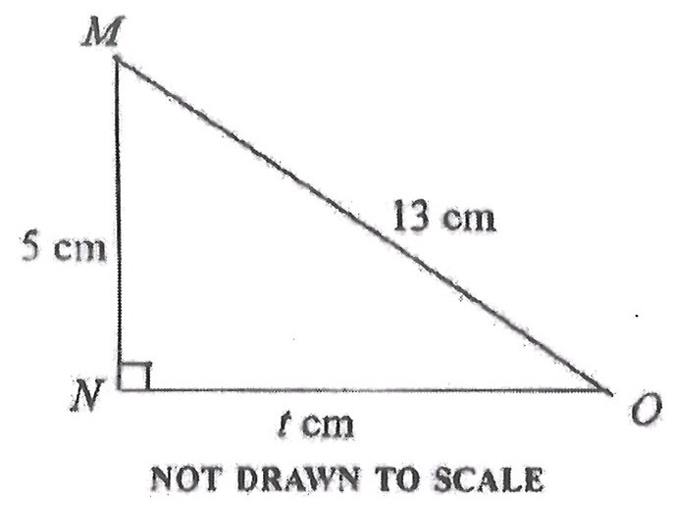
Find the value of t in the diagram.
A.
12
B.
8
C.
4
D.
3

28.

Add the following numbers: 2.4,0.042,1.12 and 0.342.
A.
2.184
B.
3.904
C.
4.282
D.
6.200

29.

Solve: 4^{x} = 32.
A.
2½
B.
3½
C.
5
D.
7

30.

Find the equation of the straight line passing through the points (-3,5) and (6,8)
A.
y = ⅓^{x}
B.
y = ⅓^{x}+6
C.
y = ⅓^{x}-10
D.
y = ⅓^{x}+14

31.

There are 15 females in a debating club. If the ratio of females to males is 3:2, how many members are in the club?
A.
6
B.
10
C.
22
D.
25

32.

If P¹(4,-5) is the image of P(x,y) translated by r = ( ⁻² ₃), find the values of x and y.
A.
(-6,8)
B.
(-6,-8)
C.
(6,-8)
D.
(6,8)

33.

If 2y = 1-3x²+4x, find y when x = -1
A.
-3
B.
-½
C.
½
D.
3

34.

Given that p = {1,2,3,4,5,6,7,8,9,10,11,12}, what is the probability of selecting a prime number from the set?
A.
⅔
B.
7⁄12
C.
½
D.
5⁄12

35.

Solve: 3 - (3x+4) ≤ -4
A.
x ≤ 1
B.
x ≥ 1
C.
x ≥ 1⅔
D.
x < 1½

36.

Two sides of a rectangle are 10 cm and 6 cm. Calculate the area of a square with the same perimeter as that of the rectangle.
A.
16 cm²
B.
30 cm²
C.
60 cm²
D.
64 cm²

37.

Make n the subject of the relation

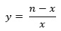
A.
n = x(y+1)
B.
n = y(x+1)
C.
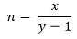
D.
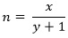

38.

Expand and simplify: (a-2)(2a+3)
A.
a² - a + 6
B.
2a² + 7a - 6
C.
2a² - a - 6
D.
2a² - 12a + 6

39.

Simplify 2² x 2⁷ ÷ 2⁴
A.
2⁻¹
B.
2⁵
C.
2¹¹
D.
2¹³

40.

If P = {7,11,13} and Q = {9,11,13}, find P ∪ Q
A.
{7,9,11,13}
B.
{7,9}
C.
{11,13}
D.
{9,13}

